[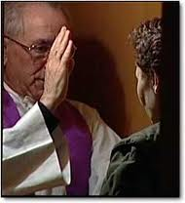](http://www.google.com.br/imgres?imgurl=http://www.parroquia-ns-europa.com/Imagenes/penitencia7.jpg&imgrefurl=http://www.parroquia-ns-europa.com/Sacramentos.htm&h=260&w=238&tbnid=LOik6_YWdcwK2M:&zoom=1&docid=sb3G9O_beR_gjM&hl=pt-BR&ei=Yh8HVL7sH4WAygT78YHYAw&tbm=isch&ved=0CFIQMygZMBk&iact=rc&uact=3&dur=1838&page=2&start=14&ndsp=23)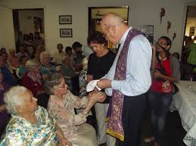[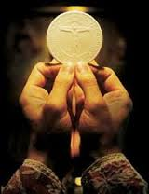](http://www.google.com.br/url?sa=i&rct=j&q=&esrc=s&source=images&cd=&cad=rja&uact=8&docid=DE5sfnBRR65WzM&tbnid=qCJ8OzpvKEfHMM:&ved=0CAUQjRw&url=http://www.katholisches.info/2014/02/05/corpus-christi-ehrfurcht-vor-altarsakrament-entscheidend-fuer-kirchliche-erneuerung/&ei=JhwHVM3CF8eqggSNzoLACQ&bvm=bv.74115972,d.aWw&psig=AFQjCNEQfCzE-owRK6NRMRgzJpeeTB2dNQ&ust=1409837878450479)[](http://www.google.com.br/imgres?imgurl=http://mundorealista.com/cristaosrealistas/files/2013/02/sagrado-matrim%C3%B4nio1.jpg&imgrefurl=http://mundorealista.com/cristaosrealistas/2013/02/18/resposta-ao-texto-o-sagrado-matrimonio-segundo-a-biblia/&h=167&w=302&tbnid=RpRAw98dxzsfcM:&zoom=1&docid=uyBYwx4gjylz6M&hl=pt-BR&ei=bR0HVP76BIKdygSXz4K4BA&tbm=isch&ved=0CFcQMygfMB8&iact=rc&uact=3&dur=1408&page=2&start=17&ndsp=22)[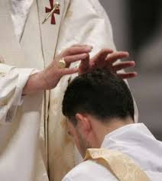](http://www.google.com.br/imgres?imgurl=http://oanunciador.files.wordpress.com/2011/05/228752.jpg&imgrefurl=http://oanunciador.com/2011/05/27/ordenacao-sacerdotal-em-ipatinga-mg/&h=320&w=286&tbnid=vPQF8pDxgTSpwM:&zoom=1&docid=YoLZcfHzxlqNWM&hl=pt-BR&ei=aSMHVM38DKLn8gHym4CYBw&tbm=isch&ved=0CDgQMygVMBU&iact=rc&uact=3&dur=1461&page=2&start=15&ndsp=21)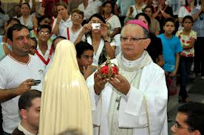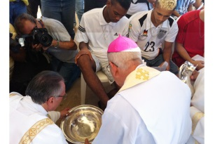[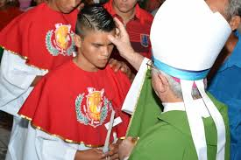](http://www.google.com.br/imgres?imgurl=http://lh5.ggpht.com/-vXy0nyLgCDs/Uxcp_E6RbLI/AAAAAAAAadI/XPZfA3uwjuE/s800/Dom%2520Lu%25C3%25ADs%2520celebra%2520Sacramento%2520da%2520Crisma%2520nas%2520comunidade%2520do%2520Cajueiro%2520Boa%2520Esperan%25C3%25A7a%2520e%2520Jacar%25C3%25A9teua%2520%252816%2529.JPG&imgrefurl=http://www.diocesedebragancapa.org.br/osdb/noticias/dom-luis-celebra-sacramento-da-crisma-nas-comunidade-do-cajueiro-boa-esperanca-e-jacareteua&h=533&w=800&tbnid=gKOZsORV7zgTfM:&zoom=1&docid=ECKaB4DiYl1pmM&hl=pt-BR&ei=vBwHVNu1G4WdygTNjIGoDA&tbm=isch&ved=0CDsQMygYMBg&iact=rc&uact=3&dur=1543&page=2&start=18&ndsp=22)[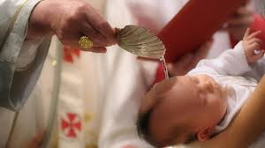](http://www.google.com.br/imgres?imgurl=http://c3press.com/wp-content/uploads/2014/06/batismo-frame.jpg&imgrefurl=http://c3press.com/o-batismo.html&h=360&w=640&tbnid=TdZ0VaqDxQZXBM:&zoom=1&docid=6lZRGs4tpznTWM&hl=pt-BR&ei=-BgHVKGXAYeqyAT_6oLgAw&tbm=isch&ved=0CFEQMygVMBU&iact=rc&uact=3&dur=1324&page=2&start=19&ndsp=23)

(DOCUMENTO DE TRABALHO)

**DIRETÓRIO**

**SACRAMENTAL**

**LITÚRGICO -**

**PASTORAL**